**Internship Report**

*Sensesemi Technologies Pvt. Ltd.*

*Reported By:*

*Harsh Hemant Balgude*

*Prajakta Bandgar*

*Pratham*

***Methods to Predict Blood Pressure from ECG and PPG Signals***

**Introduction**

The accurate prediction of blood pressure (BP) is crucial for diagnosing and managing cardiovascular diseases. This report details three methods developed during a 2-month internship at Sensesemi to predict systolic (SP) and diastolic (DP) blood pressure from electrocardiogram (ECG) and photoplethysmogram (PPG) signals.

**Data Used**

The blood pressure dataset provides clean and valid signals for designing cuff-less blood pressure estimation algorithms.

The matlab files (.mat) contain raw electrocardiogram (ECG), photoplethysmography (PPG), and arterial blood pressure (ABP) signals stored as cell arrays of matrices where each cell is one record part.

In each matrix, each row corresponds to one signal channel:

​

1: PPG signal, FS=125Hz; photoplethysmograph from fingertip

​

2: ABP signal, FS=125Hz; invasive arterial blood pressure (mmHg)

​

3: ECG signal, FS=125Hz; electrocardiogram from channel II

​

Note: Each cell is a record. There might be more than one record per patient (which is not possible to distinguish). However, records of the same patient appear next to each other.

n-fold cross test and train is suggested to reduce the chance of train set being contaminated by test patients

**Method 1: 1D CNN Sequential Regression Model**

***Objective:***

To predict SP and DP using a 1D Convolutional Neural Network (CNN) that processes ECG and PPG data through separate channels.

***Architecture:***

- *Input:* Dual-channel input for ECG and PPG signals.

- *Layers:*

- Convolutional layers for ECG and PPG inputs to extract relevant features.

- Concatenation layer to merge features from both signals.

- Fully connected layers for regression output.

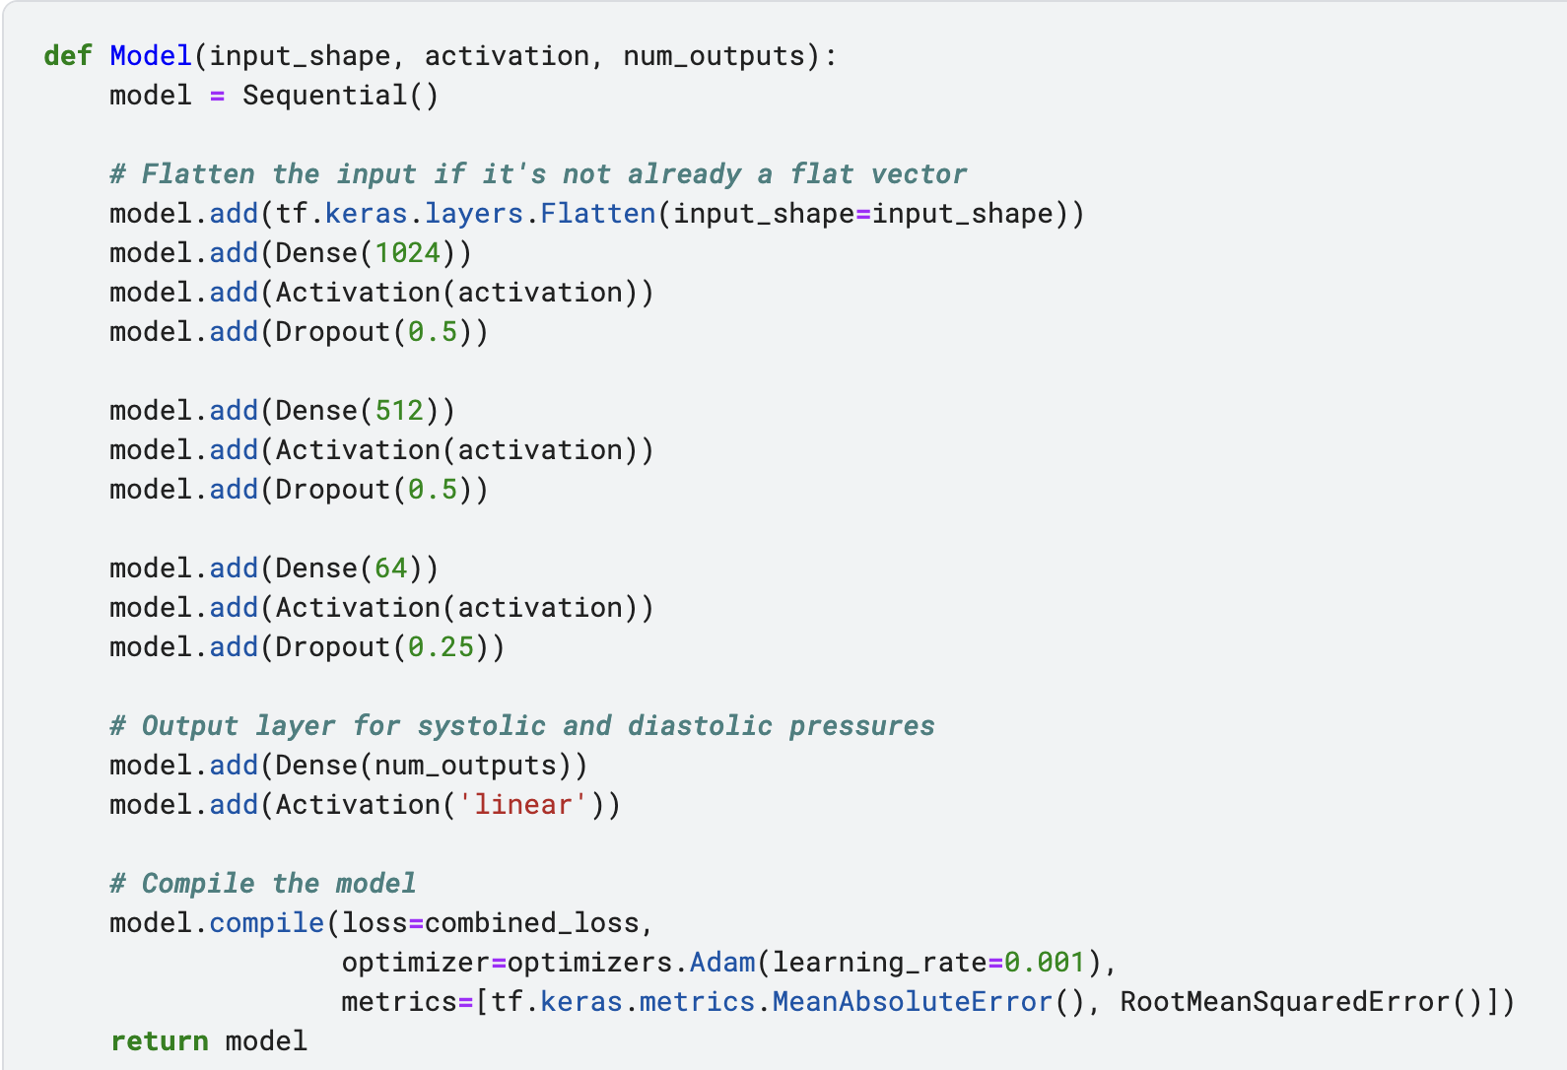

***Steps:***

1. *Preprocessing:* Normalize ECG and PPG signals to have zero mean and unit variance.

2. *Feature Extraction:* Apply multiple 1D convolutional layers with ReLU activation and pooling layers to extract temporal features from ECG and PPG signals.

3. *Fusion:* Concatenate the features from both signal channels.

4. *Regression:* Use fully connected layers to predict SP and DP.

***Results:***

The model achieved high accuracy in predicting blood pressure, with the mean absolute error (MAE) and root mean square error (RMSE) metrics used to evaluate performance.

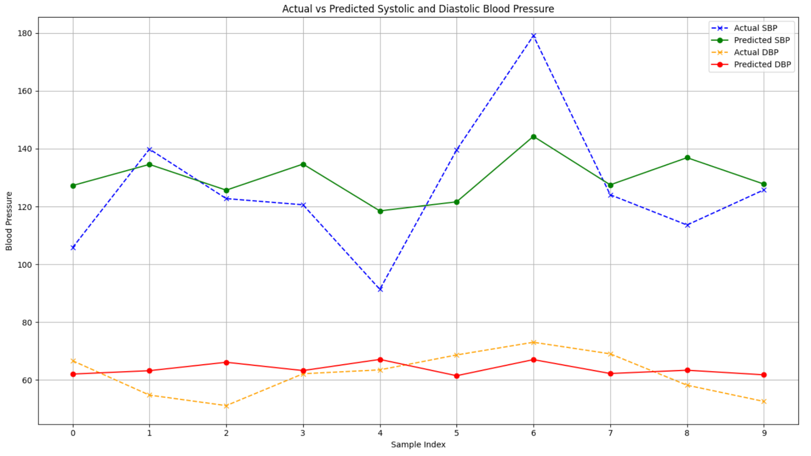

**Method 2: Time Series UNet Model**

***Objective:***

To enhance feature extraction from ECG and PPG signals using a Time Series UNet architecture before feeding these features into a sequential regression model.

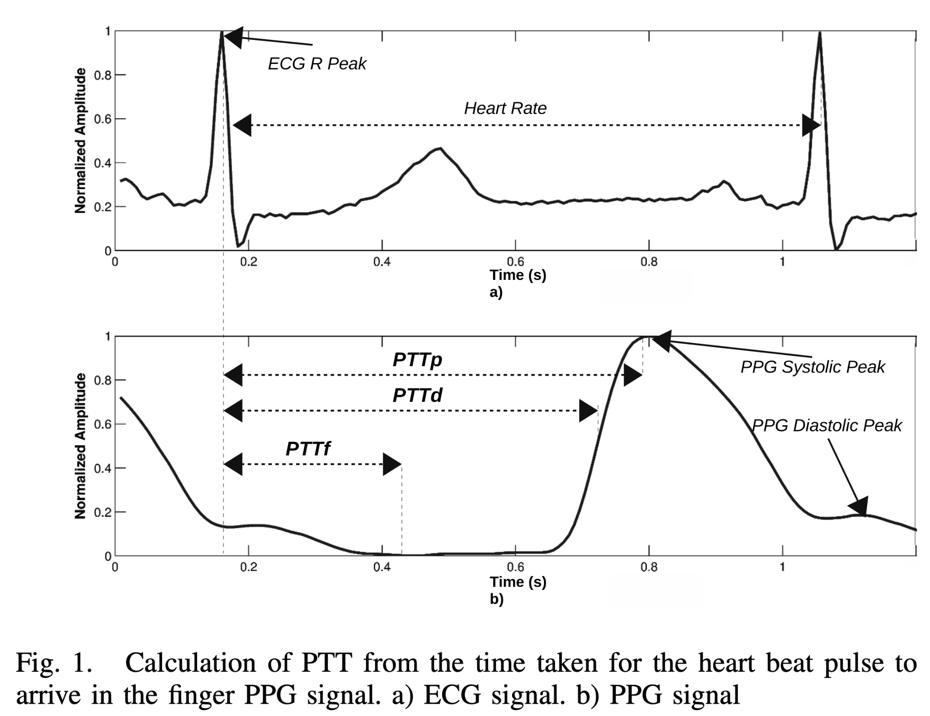

***Architecture:***

- *UNet Encoder:* Extracts features R - Peak from ECG and PPG signals.

- *UNet Decoder:* Reconstructs the feature map to maintain temporal context.

- *Sequential Regression:* Predicts SP and DP from the extracted features.

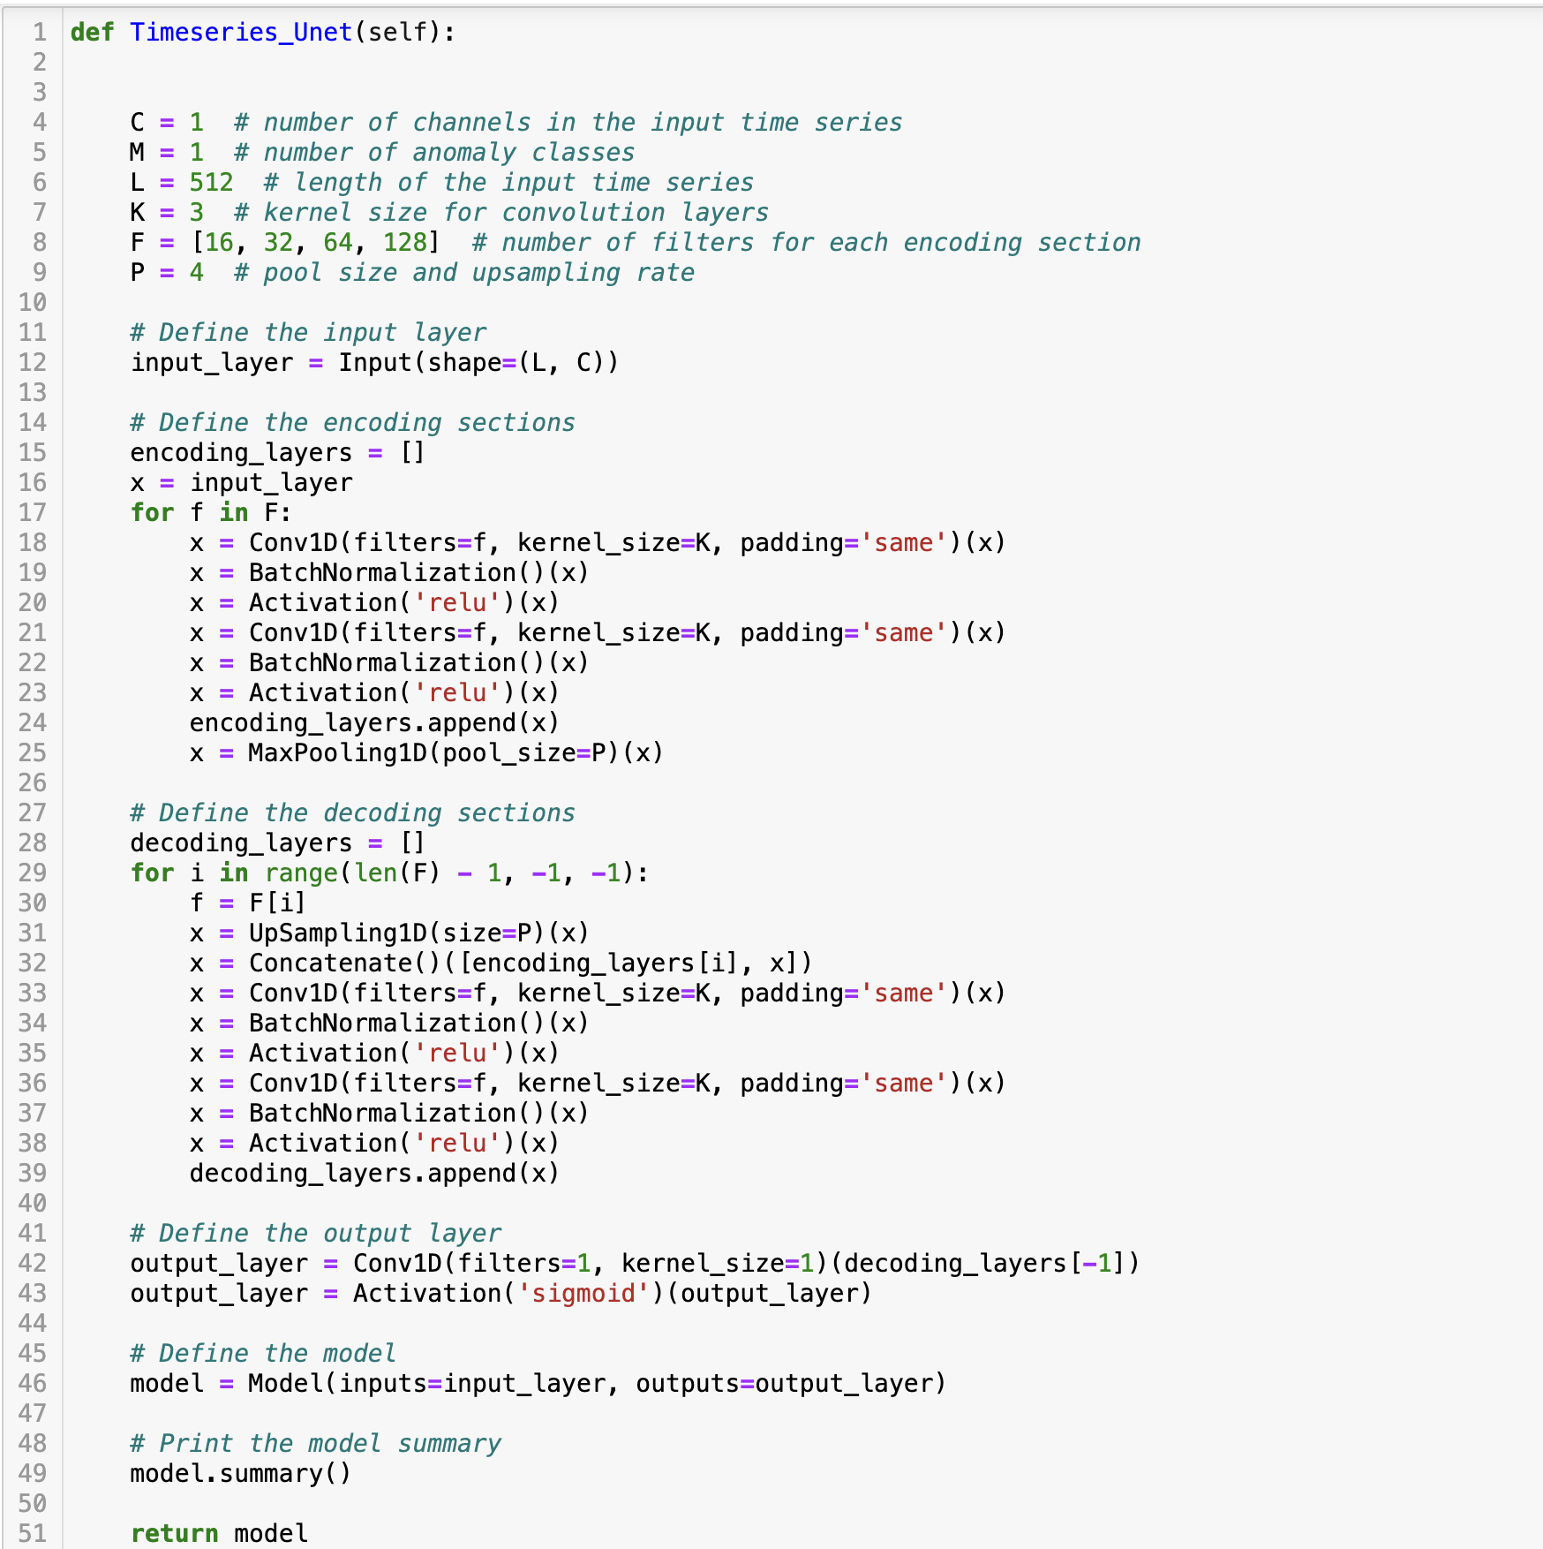

***Steps:***

1. *Preprocessing:* Normalize ECG and PPG signals.

2. *UNet Encoding:* Pass ECG and PPG signals through separate UNet encoders.

3. *Feature Fusion:* Merge the encoded features.

4. *UNet Decoding:* Decode the combined features to retain spatial and temporal information.

5. *Regression:* Predict SP and DP using fully connected layers.

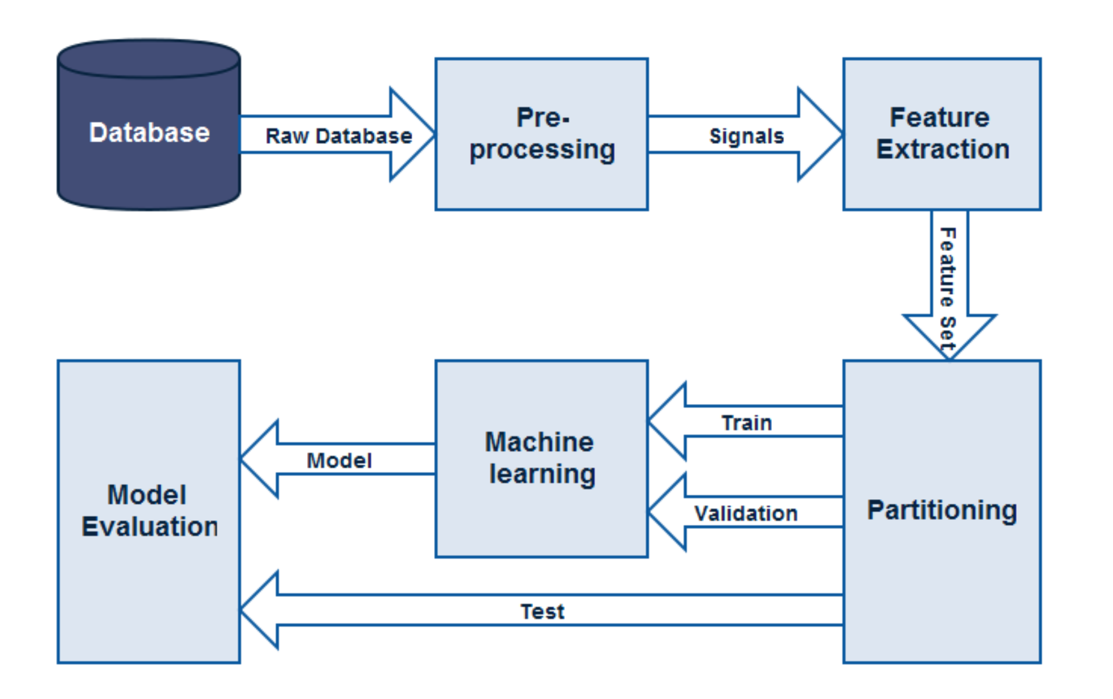

***Results:***

The time series UNet model showed improved performance over the 1D CNN, particularly in capturing complex patterns within the signals.

**Method 3: Formula-Based Approach Using Pulse Transit Time (PTT)**

***Objective:***

To predict BP using a formula-based approach that uses Pulse Transit Time (PTT) calculated from ECG and PPG signals.

***Principle:***

PTT is the time interval between the R-peak of the ECG signal and a characteristic point on the PPG signal (e.g., the foot of the waveform). It is inversely related to blood pressure.

***Formula:***

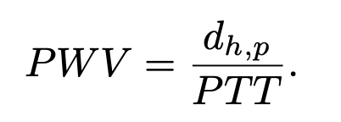

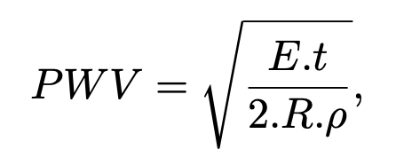

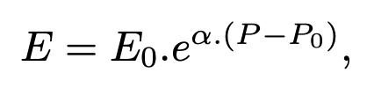

Here,

PTT : Pulse Transit Time  
 PWV : Pulse Wave Velocity

dh,p : Distance between the Heart and the peripheral, which is related to the person’s height

E : Young’s Modulus of the blood vessel

t : Vessel Thickness

ρ : Blood Density

R : Inner Radius of the Vessel

P : Blood pressure in arteries

***Steps:***

1. *PTT Calculation:* Use the Time Series UNet model to identify R peaks in the ECG Signal and Sys peak in the PPG Signal. Getting the distance between these will give us PTT.

3. *BP Calculation:* Apply the linear formula to estimate SP and DP.

***Results:***

This method provides a quick and computationally efficient way to estimate BP. However, its accuracy is highly dependent on the calibration of the various parameters mentioned in the above formula

**Conclusion**

Each method developed offers unique advantages and challenges in predicting blood pressure from ECG and PPG signals. The Regression model provides a straightforward approach with good accuracy, the UNet model enhances feature extraction and overall performance, while the formula-based approach offers computational efficiency while eliminating the need of the BP ground truth.

**References**

1. Mohamad Kachuee, Mohammad Mahdi Kiani, Hoda Mohammadzade & Mahdi Shabany

(2015). Cuff-Less High-Accuracy Calibration-Free Blood Pressure Estimation Using Pulse Transit Time.

2. Xiaorong Ding, Wenxuan Dai, Ningqi Luo, Jing Liu, Ni Zhao & Yuanting Zhang (2015). A Flexible Tonoarteriography-Based Body Sensor Network for CufflessMeasurement of Arterial Blood Pressure.

3. S. Z. Mahmoodabadi, A. Ahmadian, M. D. Abolhasani, M. Eslami & J. H. Bidgoli (2005). ECG Feature Extraction Based on Multiresolution Wavelet Transform.

4. Wan-Hua Lin, Fei Chen, Yanjuan Geng, Ning Ji, Peng Fang & Guanglin Li (2020). Towards accurate estimation of cuffless and continuous blood pressure using multi-order derivative and multivariate photoplethysmogram features.